THEY COME AT NIGHT
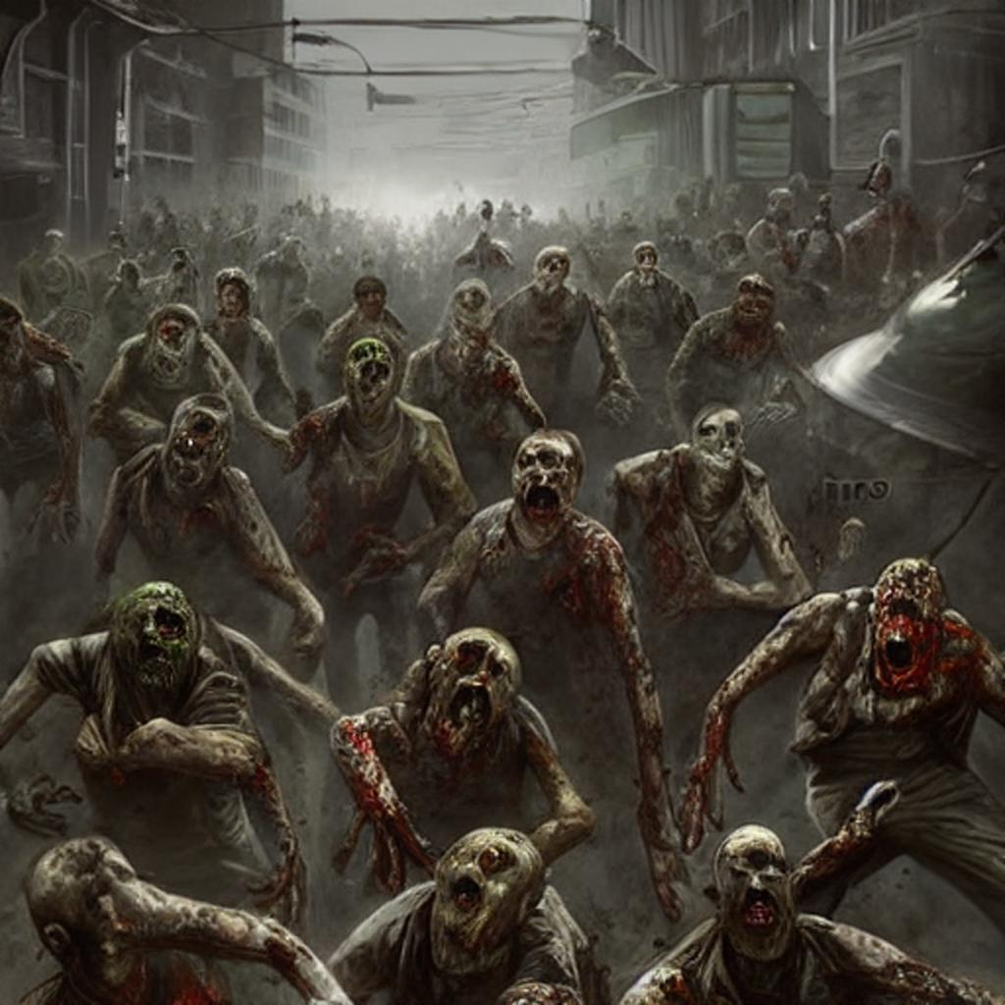
GAME MANUAL

Table of Contents
Daytime Play 3
Day Playfield 5
Barriers and Traps 5
Using Resources 6
Nighttime Play 7

End of Days

The End of Days is upon us and you have been chosen to defend the last of us from the hordes of hell-spawn that have been unleashed upon the Earth to ravage the remaining souls.
You must build up your compound during daylight hours and defend it from the throngs of undead creatures when night falls. Your resources are limited, so you will have to use and distribute them wisely.
Your weapon is a Winchester model 1895 30-06 Springfield lever-action rifle. Initially, you will be supplied with three fragmentation grenades and 100 rounds of ammunition for your rifle.
If your inventory falls below 100 rounds, you will be supplied with an additional 100 rounds at dawn. If your inventory falls below three grenades, you will be supplied with three additional grenades.
You will be given 500 credits to start with. Use this money to purchase supplies to bolster the defenses of your compound. During the day, reinforce your fort with barriers and traps purchased from your local supplier.
You will be awarded a bounty of 10 credits for each undead creature you slay. For each day you survive, you will be gifted a bonus of 100 credits. Use your credits wisely to fortify your compound for each advancing horde.
During the night, you will have the opportunity to replenish supplies by collecting various items that will be airdropped to you. This is a very dangerous endeavor so only attempt retrieval when absolutely necessary.

Daytime Play
To start the game, press any key other than Q or SPACE. You will begin the game with 500 credits which you can use to purchase materials to fortify your compound against the coming undead horde.
You will be given 100 rounds of ammunition and 3 grenades to start with. At each dawn, you will be given an additional 100 rounds should your ammunition fall below 100. Similarly, you will be given 3 additional grenades should your supply fall below 3.
To select the desired material from the supplies display (fig. 1), move play-field placement cursor to the empty space in center of play-field and press and hold joystick fire button to transfer control to supply selector

Figure 1
Move joystick to position supply selector over desired resource. Cost of resource will display at bottom of the supplies display. Transfer control to play-field selector by releasing fire button.
To purchase selected resource, position play-field selector to desired play-field location and press fire. Resource will be placed in selected location if cost of resource is less than or equal to remaining credits (fig. 2)

Day Playfield

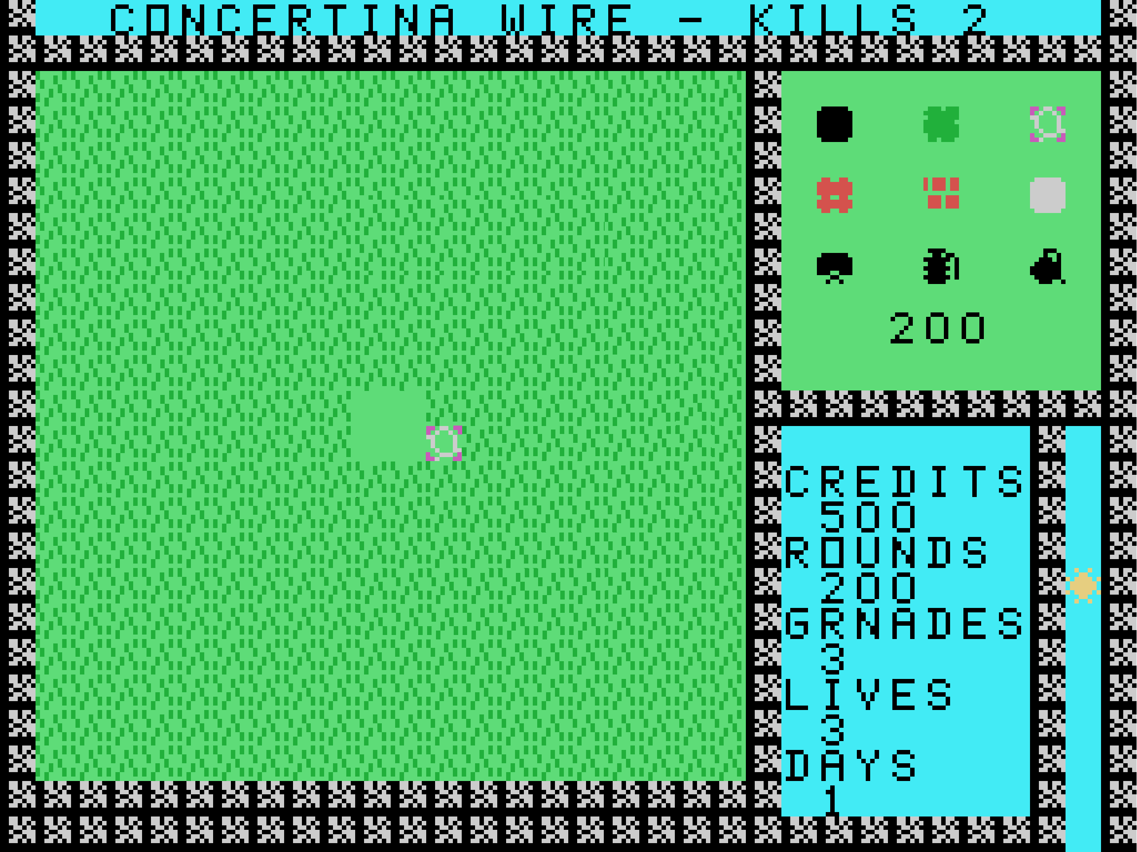
Figure 2
Continue to place resources until you run out of credits or time. The sun icon at the lower right of the screen displays the time remaining till nightfall. When it reaches the bottom and disappears, night play will begin.
The resources available for fortification are listed in Table 1. Use resources to counter the upcoming undead horde. Some resources are more effective than others against a particular type of enemy – you must use them wisely to repel the coming attacks with the utmost efficiency and guarantee your survival to the next day.

Barriers and Traps

Image | Name | Cost | Description | Effective Against
 | Hole | 0 | No cost resource but takes time to generate. Eliminates a single foe | Gobliks, Demoks, Zombeys
 | Shrub | 150 | Destroyed by all foes. Damaged shrubs regenerate | All
 | Concertina Wire | 200 | Incapacitates two foes | Gobliks, Demoks, Zombeys
 | Fence | 250 | Destroyed by Zombeys and Ghosps | All esp. Gobliks and Demoks
 | Brick Wall | 300 | Destroyed by Zombeys and Ghosps | All esp. Gobliks and Demoks
 | Stone Wall | 350 | Destroyed by Demoks and Zombeys | All esp. Gobliks and Ghosps
 | Claymore | 350 | Destroys everything in directional blast area | Gobliks, Demoks and Zombeys
 | Fragmentation Grenade | 350 | Destroys all adjacent foes, barriers and traps | Gobliks, Demoks and Zombeys
 | Incendiary Grenade | 500 | Destroys adjacent foes, barriers, traps. Generates firewall that destroys foes until quenched. | Gobliks and Zombeys
 | Head Stone | NA | Player death marker. Only Gobliks destroy Head Stones. | Demoks, Zombeys and Ghosps
Table 1

Using Resources

Resources are used as either barriers or traps. Barriers will stop the movement of approaching foes until the barrier is destroyed. Traps can kill foes depending on the type of trap and type of foe (not all traps are triggered by all foes). Fence and Brick can be damaged by bullets. All barriers and traps can be destroyed by an explosive blast.
Claymore mines have a directional blast and should be rotated to provide the optimum blast direction. To rotate, place the selection cursor over the mine and press the fire button. Continue pressing the fire button until the claymore is facing the desired direction.
Explosives can be triggered by bullets. When detonated, explosives will kill any kind of foe, even foes that do not normally trigger an explosive trap (such as Ghosps).
Game statistics are displayed in the lower right portion of the screen (fig. 3). Statistics include important information such as number of credits, number of ammunition rounds, number of grenades, player lives and days survived.
Daytime play ends when the sun goes down and is no longer visible. When this occurs, the selector cursors will disappear and the player icon will appear in the center of the screen and Nighttime play begins.
Figure 3

Nighttime Play

When night falls, the play-field will change color and the moon will appear in the timer location. The player icon will appear in the center of the play-field. Each night, a horde of undead creatures will attack the player and stronghold. Defend yourself using weapons and traps.
The player moves in one of four directions (NSEW) using the joystick. If the player has ammunition, they will be able to fire the rifle in direction they are facing by pressing joystick fire button. Player must use the rifle to defend themselves from attacking undead foes.
Player can also use the rifle to trigger explosive traps that have been placed on play-field during daytime. Player is also able to use the rifle to damage and destroy some barriers placed during daytime play.
Grenades can be thrown by player by pressing and holding joystick fire button and pushing joystick in direction of throw. There are some circumstances where player can be killed by the grenade or an explosive trap.
Player will face 4 different types of undead foes. Each has their own strength and weakness and are detailed in Table 2.
 | Name | Strength | Weakness
 | Goblik | Destroys Head Stones | Blocked by fence, brick and stone
 | Demok | Invulnerable to fire | Blocked by fence and brick
 | Zombey | Destroys all barriers | Vulnerable to all traps
 | Ghosp | Does not trigger traps | Blocked by stone
Table 2

Bonus Items

Bonus items will be dropped onto the play-field during the night. These items will provide the player additional resources to aid in the fight against the undead. The bonus items are detailed in Table 3.
 | Name | Description
 | Ammo | Provides an additional 100 rounds
 | Grenades | Provides an additional 3 grenades
 | Credits | An additional 2000 credits are given
 | Extra Life | Player gets a bonus life
Table 3

Nighttime play ends when the moon drops out of visibility or the player loses a life. If the player has any lives remaining, the play-field will change to reflect the daytime and play will begin the next cycle.

Tips and Tricks

Listed below are some tips and tricks to help survive the apocalypse.
- Bonus items are extremely hard to pick up without getting killed.
- Each foe has its own strength and weakness. Use this knowledge to prepare for the upcoming wave. The wave order is Goblik, Demok, Zombey, Ghosp.
- Don’t forget about your grenades. They are useful when attempting to retrieve a bonus item,
- If you attempt to pick up a bonus item, do it right before dawn. This reduces the amount of time you will need to fight off the horde.
- Once you acquire the bonus item, head for the nearest corner. You will only need to defend from 2 directions once you reach it.
- Use incendiary grenades when you are low on ammo if you can afford them.
- Protect Head Stones from Gobliks.
- Trigger explosive traps with gun on Ghosp phase.
- Explosive traps and grenades can kill you, so be careful.
- Try to have just less than 100 rounds at dawn. Also try to have two grenades at dawn.
- The longer you survive, the less ammo you are awarded so it may become necessary to pick up the ammo bonus in advanced stages.
- Explosives can destroy traps and barriers. Be careful where you place them.
- Use the ‘Z’ key to pause the game.
- Before you start the game, the chyron at the top of the screen will give some descriptions of the game play. Use the SPACE bar to advance the chyron text.
- You can use barriers to corral foes, allowing you to get bonus item(s).

Credits
All concepts, design, artwork, music, programming and testing created and performed by Brian Gray.

Special thanks to tmop69 from the AtariAge TI99/4A user group.

